D & J Tech Solutions

**Flash as Pies – Project Plan**

## Iteration 1: Week one 30/6 – 6/7

* Project *Kitchen Inventory Management System* Created on Github
* Create Repository
* Create Development environment, virtual env., install Django
* Create Landing page
* Create Products page
* Create Staff page
* ERD Model
* Requirements doc
* System design doc
* Wireframes
* Planning/Contract
* User Stories

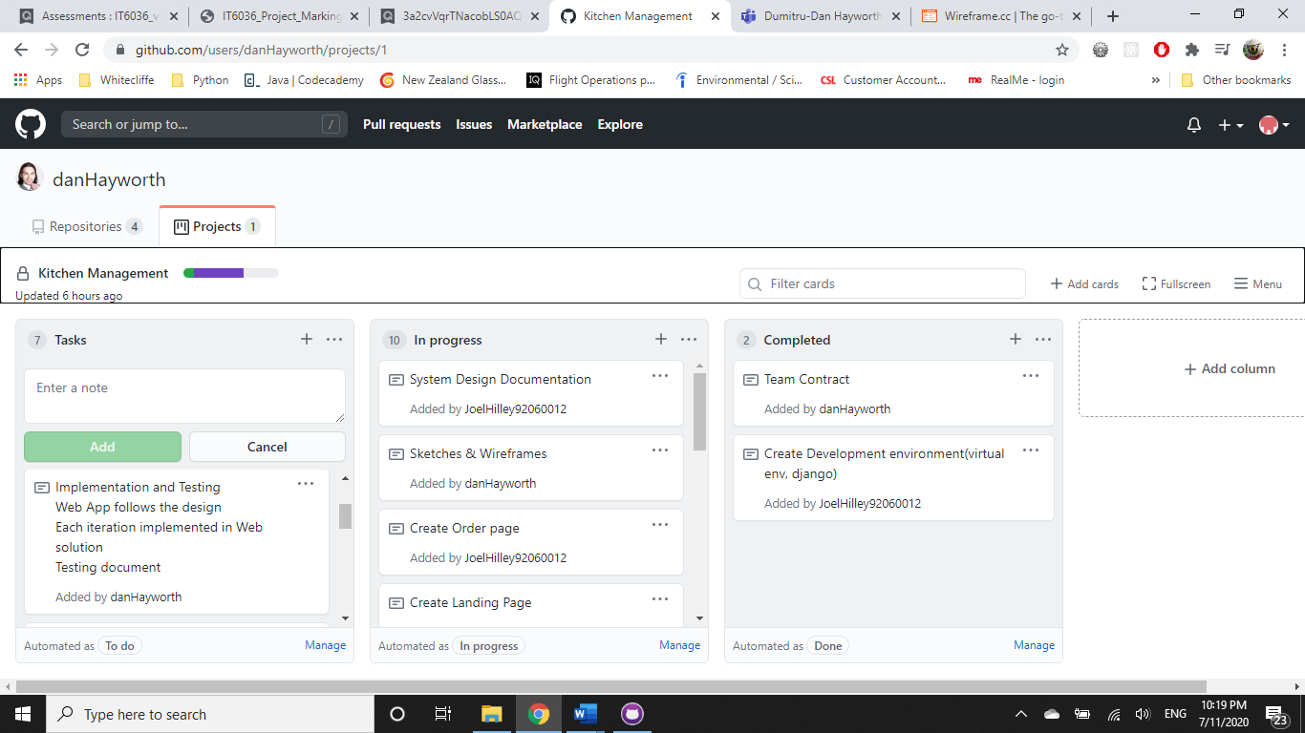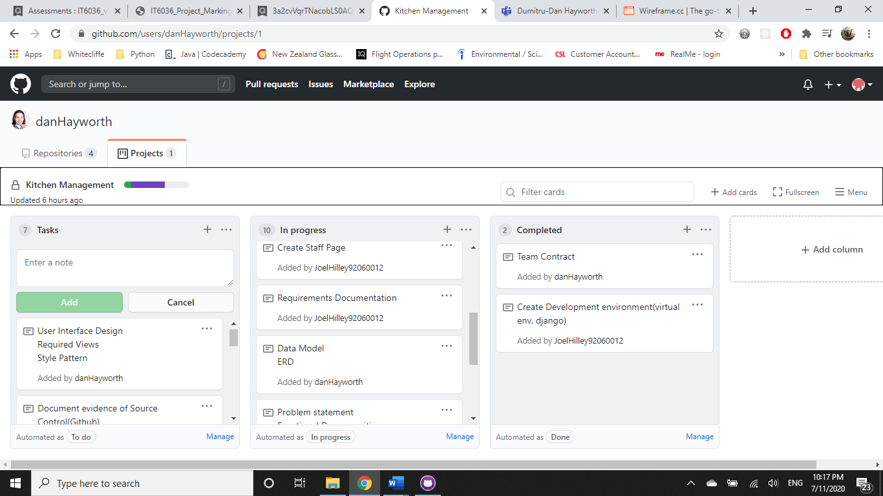

## Iteration 2: 7/7 – 10/7

* Create Levels of authentication based on account type / user story
* Functionality for user stories
* Remove usage table
* Add employee contact details
* 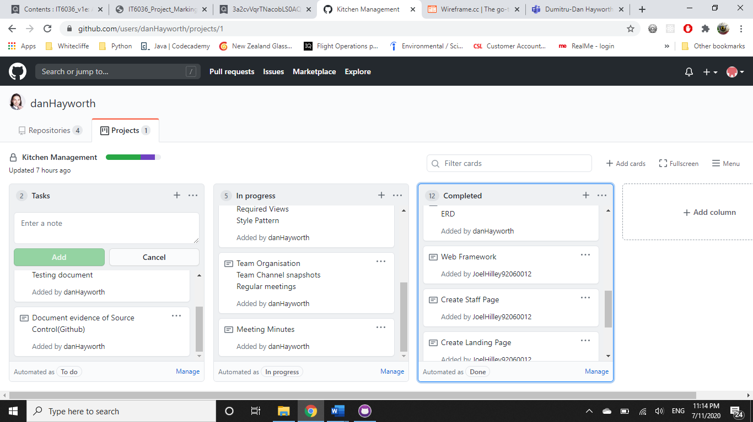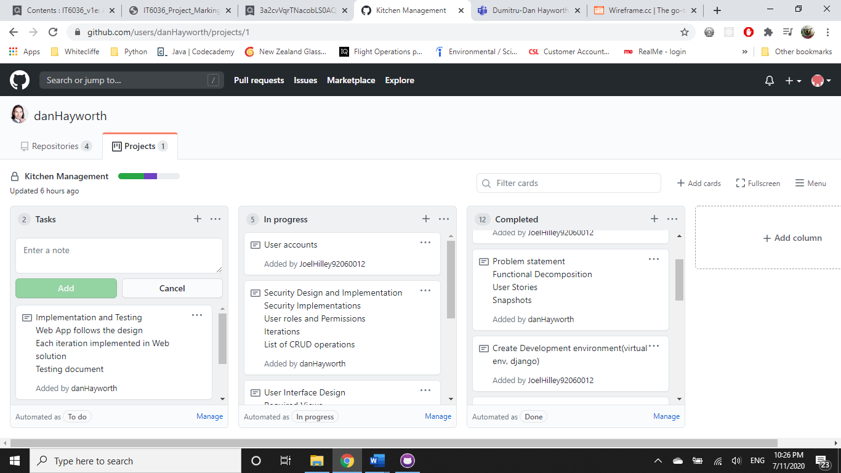UI color design

## Iteration 3: 11/7 – 12/7

* Placed orders are marked as ordered by a checkmark in an additional column.
* 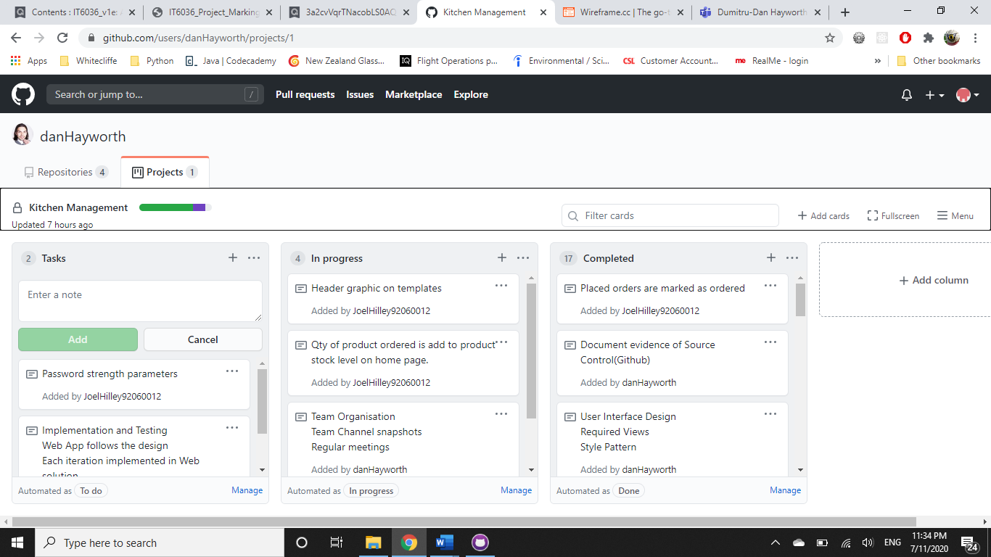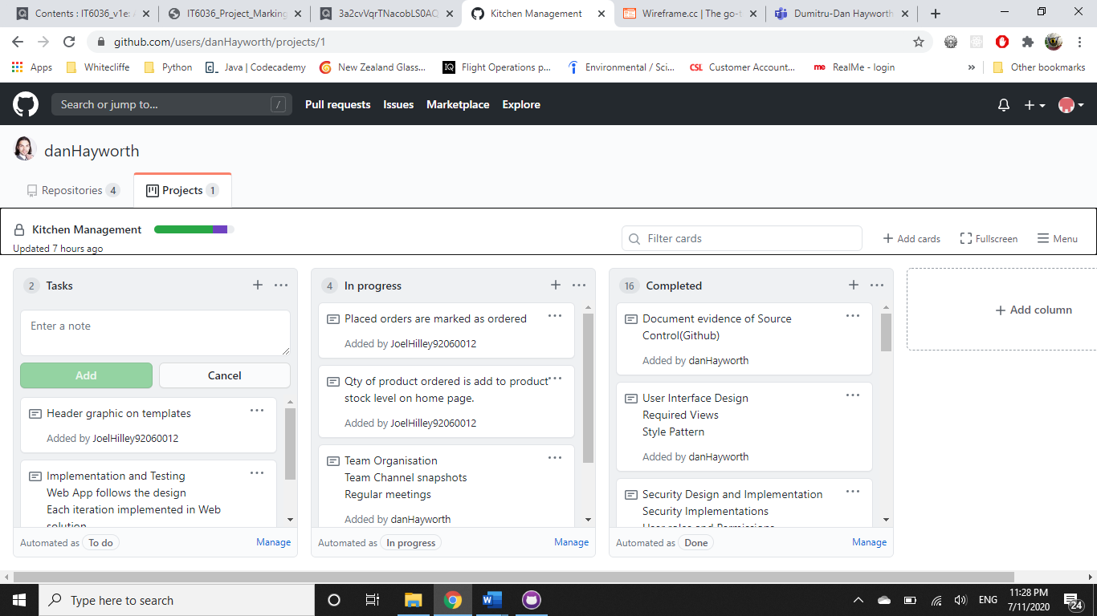Image added in header of pages

## Backlog

* Placed order updates product quantities
* 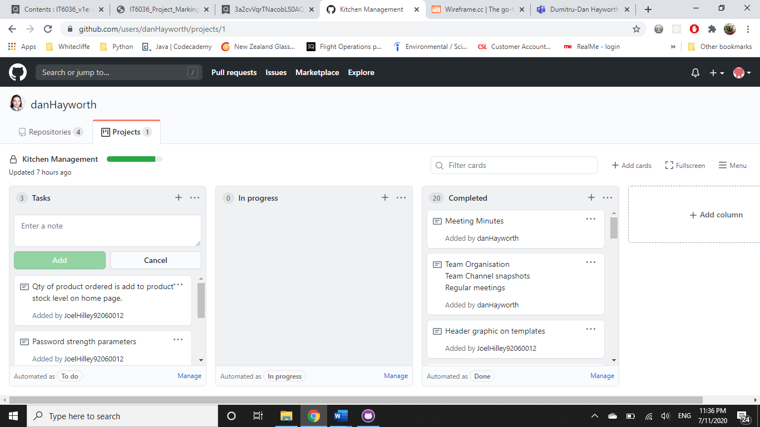Strong password enforcement when creating accounts